**Omar talal saleh** 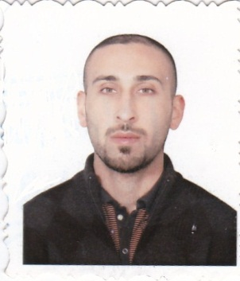

Place of birth: Iraq - Baghdad

Date of Birth: 18-02-1981

Gender: Male

Place of residence: baghdad

Marital Status :Married

Phone: 07712222880

Email: www.otalal98@gmail.com

Skybe: omartalal30

Specialization: warehouse manger/sales manger

**EDUCATION/DEGREES**

Education: Bachelor/English literature

**Name of the university: Mustansiriya University**

**Graduation Year: 2006**

**PROFESSIONAL EXPERIENCE**

MS-office (word,l,outlook)

Internet & e-mail management

English & Arabic typing

Computer Networks

Warehouses management

sale manger

logistics

Sap system

**Work history**

**Fuchs Oil Company /modren electronic in iraq (SONY)**

1-Worked in FUCHS oil company in baghdad as warehouse manager well as filters equipped

2-The nature of my work requires processing filters to the Iraqi market as well as I make daily inventories of immediate matching material processed and also monthly and matching that to know the material to be provided in addition to the annual inventory to determine the size of sales

3-Of the nature of my work as well as sending bills to the size and the preparation of filters that should be available in the market, and receive incoming trucks from Jordan and to that should be available in the market, and receive incoming trucks from Jordan and to computer in Baghdad, Amman and so powerfully completely.Sales manager in this company as well as work for more than a year

4- I work in fouchs oil company about five years from2008 to2013.

Thean i work in modren electronics (SONY) in iraq as supervisor storekeeper we used SAP system in my work

I work about one year in this company

Working with SONY gave me more experinces big addition to the years of experiense that i own using the global system SAP

Language. /arabic. English